PRACTICAL-1

Aim:- Study Cisco Packet Tracer basics, OSI and TCP/IP network models, and fundamental transmission media concepts including cable types, communication modes, bandwidth, delay, and multiplexing.

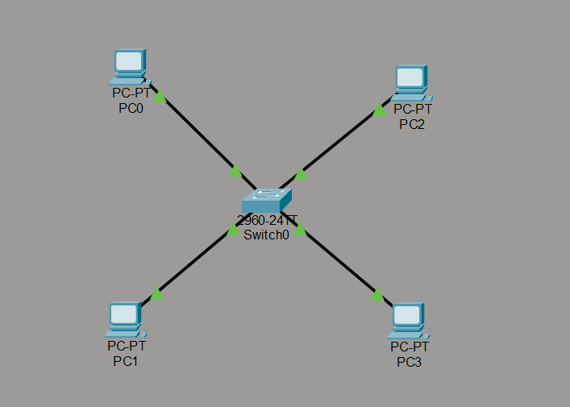
Figure 1 System of 4 PC connected via Switch

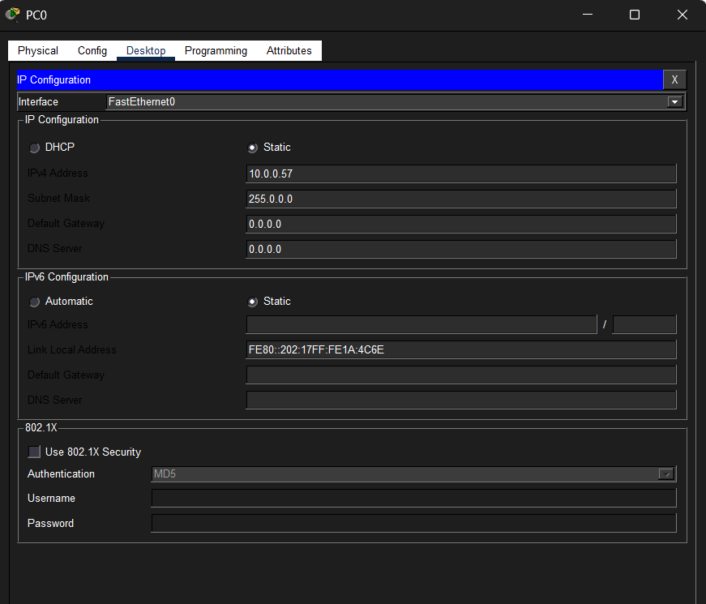
Figure 2 Ip config of PC 0
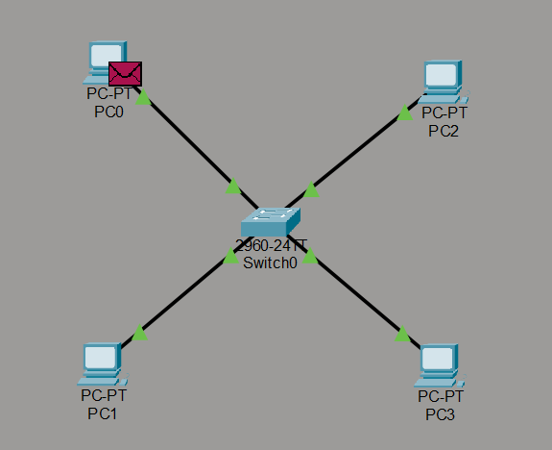
Figure 3 sending message from PC0

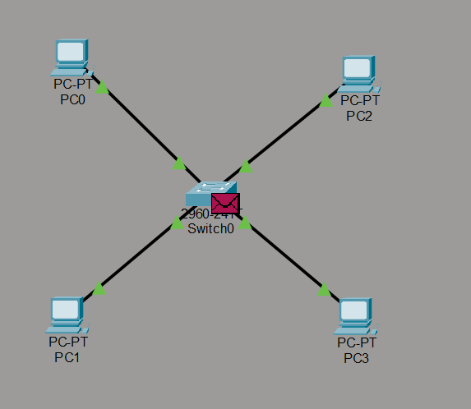
Figure 4 Message received at switch
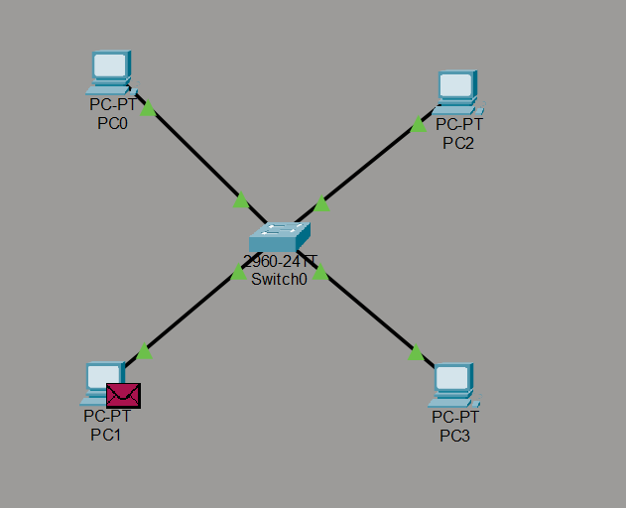
Figure 5 message received at PC 2

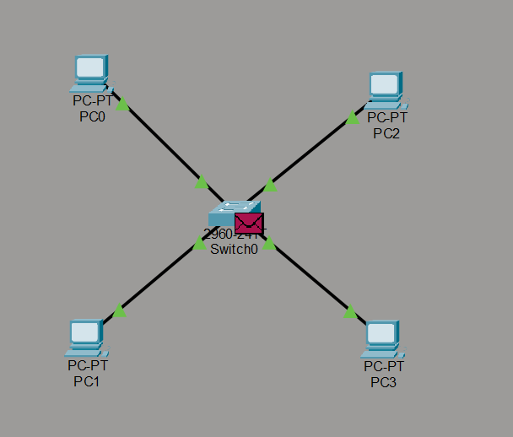
Figure 6 Reply message from Pc 2 received at switch
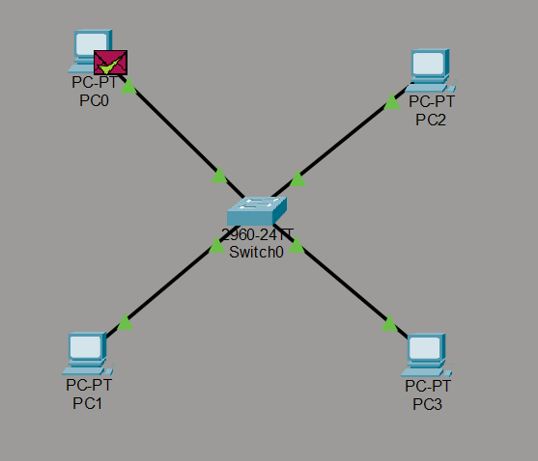
Figure 7 Reply message received at PC0

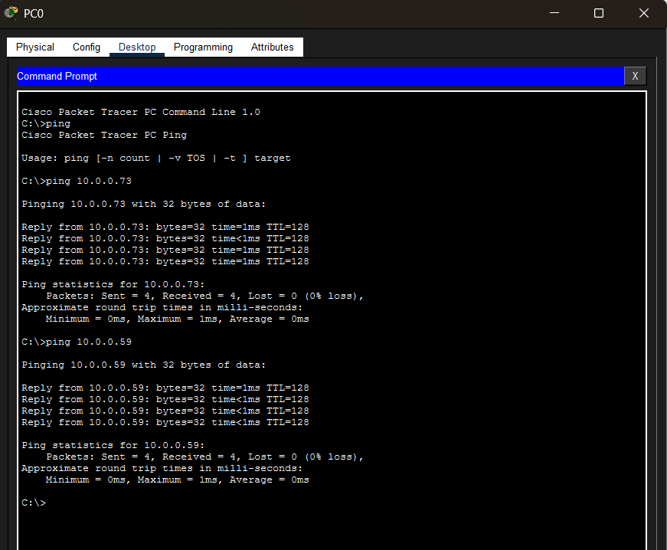
Figure 8 Checking if pinging is done or not

